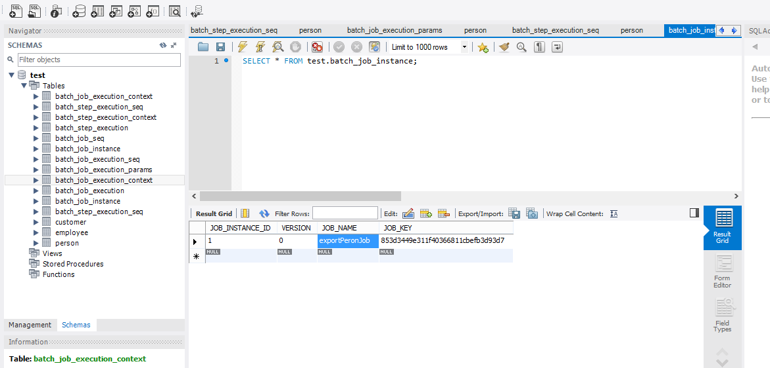

@Bean

**public** Job exportPerosnJob() **throws** UnexpectedInputException, ParseException, Exception{

**return** jobBuilderFactory.get("exportPeronJob").incrementer(**new** RunIdIncrementer()).flow(step1()).end().build();

}

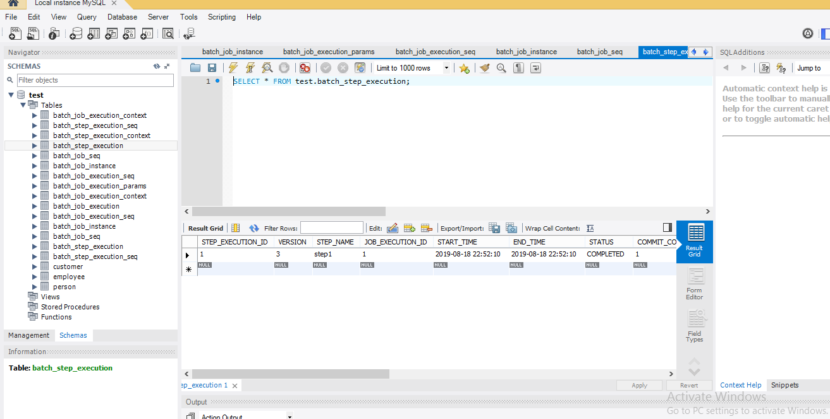

//

{"map":[{"entry":[{"string":"JdbcCursorItemReader.read.count","int":11},{"string":["batch.taskletType","org.springframework.batch.core.step.item.ChunkOrientedTasklet"]},{"string":["batch.stepType","org.springframework.batch.core.step.tasklet.TaskletStep"]}]}]}

